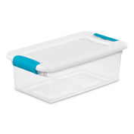
- 1 Clear (15 quart) plastic box with latching lid
- 2 sturdy pencil pouches (large enough to hold the supplies)
- 2 red checking pencils or pens
- #2 pencils (pre-sharpened)
- 1 pencil sharpener (enclosed to catch the shavings)
- Large white eraser
- Erasable pens (blue/black)
- 1 set of colored pencils
- 1 box of crayons (24 count- no larger)
- 1 set of watercolor markers
- 2 extra fine-line black sharpie markers
- 1 2-inch, 3-ring binder
- Dividers for binder
- 6 composition books (can vary in color)
- Wide-ruled loose leaf paper (2 packs)
- Blunt scissors
- 4 glue sticks
- 1 Elmer’s liquid glue
- 3 highlighters (different colors)
- 2 boxes of Kleenex
- 2 rolls of paper towels
- 2 Clorox/Lysol wipes containers
- 1 hand sanitizer – individual size for supply box
- Set of multiplication and division flash cards (to be kept and practiced at home)

